The Battle of the Neighbourhoods – Report

1. Introduction & Business Problem:

Opening up a business in any area requires a lot of research and analysis. Opening a restaurant business can be quite tricky as it requires a lot of information gathering as well as competitor analysis.

Also it requires which area will be suitable for which category of cuisines. We need to study various factors such a total population, city demographics, competitors, supply of raw ingredients, menu analysis, price analysis, overhead cost and many other factors which can include fixed or variable cost. We will create and observe which area will be most suitable for current opening of restaurant as well as for future investment in NY City. With this project we will find out the best location or neighbourhood which will be best suitable for Italian restaurant.

2. Data:

This section will cover how we will use data to solve the problem. Foursquare API have a database of over 100 million places, we will use this API to gather primary data source. This API will provide us with the ability to perform search, location sharing and details of business. Images through this API will also help in making it more interactive.

Data sources: <https://cocl.us/new_york_dataset> , Foursquare API

Analysis

Following are required libraries for Python.

* Pandas and Numpy for data.
* Foursquare API to get details.
* New York City coordinates using geopy.
* Map visualization using Folium

Results

1. Queens have the highest number of neighbourhood

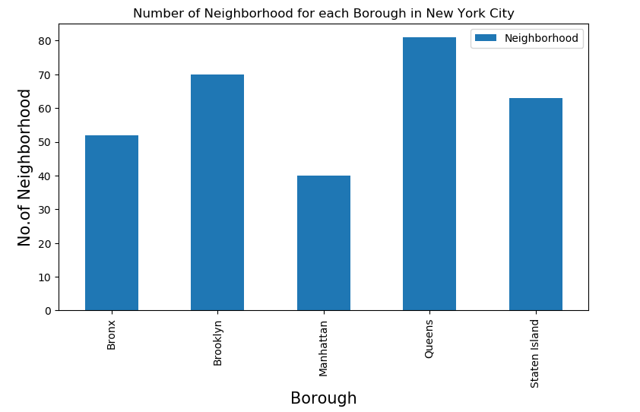

1. Belmont has the highest number of Italian restaurants.

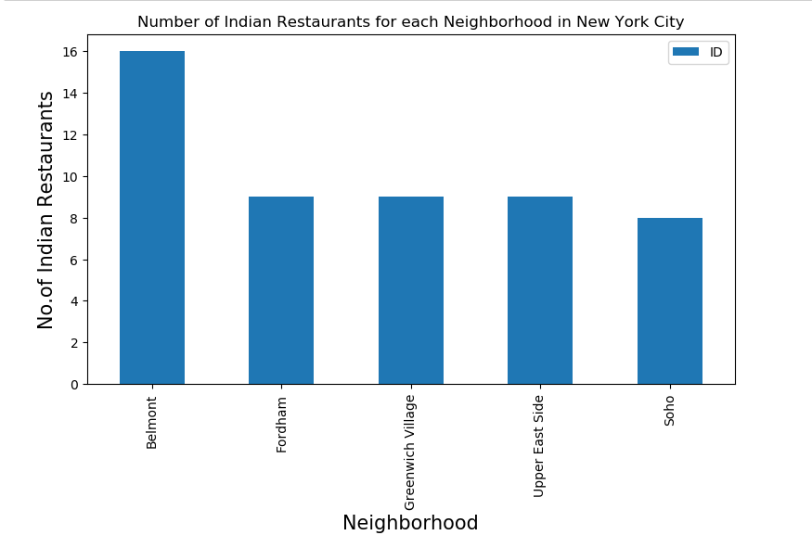

1. Borough Bronx have the highest average rating of Italian Restaurants which is above 7.5

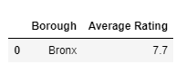

1. Belmont has the highest average rating for Italian Restaurants.

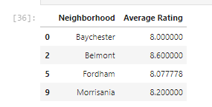

1. Best neighbourhoods in New York that has highest average rating for Italian Restaurants.

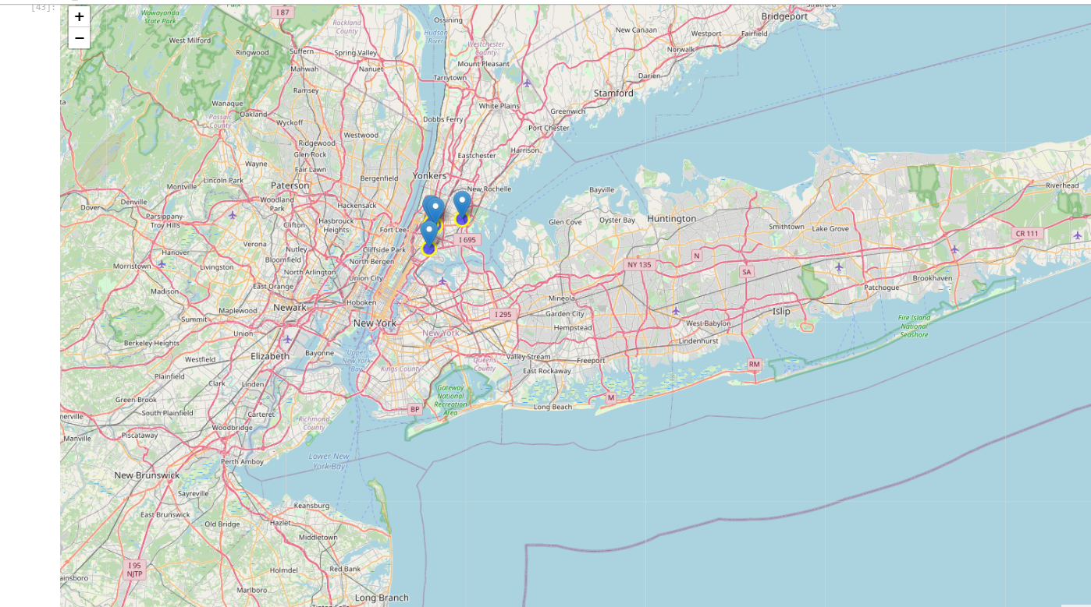

Conclusion:

1. Bronx have majority of Italian Restaurants
2. Best neighbourhood for Italian restaurants in Bronx are;
   1. Belmont
   2. Morrisania
   3. Fordham
   4. Baychester
3. Bronx have the potential of Italian cuisines market so its recommended to select location near Belmont

NOTE – Recommendation is provided on the basis of Avg User ratings